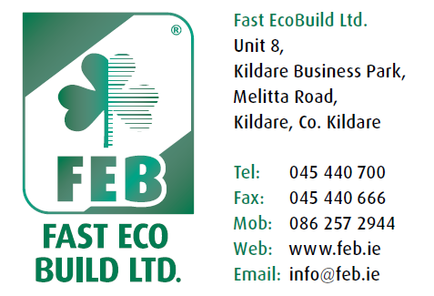
FAST Ecobuild Ltd.

Customer Complaints Procedure

Contractor’s Name: ________________________
Company Name: ___________________________
Contractor’s Address: _______________________
_________________________________________
Date: __/__/__

Complaint Procedure to be carried out by Contractor
In the event of a customer having a complaint in relation to the External Insulation System applied to their residence, they shall first contact the contractor who carried out the installation and inform him of the details of the complaint.

The Contractor shall first record these details onto a Q10 form (attached) before visiting the site to inspect and discuss the resolution of the complaint with the client. The Contractor must make every effort to resolve the issue with the client.

However, if the issue becomes a dispute between both parties, in relation to the External Insulation System, then FAST EcoBuild Ltd will attend the site at an agreed time to meet both parties and offer technical advice as to how the issue should be resolved.

COMPLAINT FORM Q.10 Ref No. _______

Received From
Name: ___________________________________
Address: ____________________________________________________
____________________________________________________________
Contact No: ____________________________
Details of Complaint:

Material Issue:
Application Issue:
Aesthetic Issue:
Other:
Not a Complaint

Photo’s Attached If Possible: Yes No

Material Type: ______________________________________________
Batch No: __________________________________________________
Site Address: ________________________________________________
___________________________________________________________

Decision:
Corrective Action (if applicable): __________________________________
____________________________________________________________________________________________________________________________________________________________________________________________________________________________________________________________________________________________________________________________________________________________________________________________________________________________________

Preventive Action (if applicable):__________________________________
____________________________________________________________________________________________________________________________________________________________________________________________________________________________________________________________________________________________________________________________________________________________________________________________________________________________________

Conclusion / Outcome:
___________________________________________________________________________________________________________________________________________________________________________________________________________________________________________________________________________________________________________________________________________________________________________________________________________________________________________________________________________________________________________________________________________________________________________________________________________________________________________________________________________________________________________________________________________________________________________________________________________

Letter Sent: Yes No

Signed:__________________________ Date: __/__/__

